# Task 1



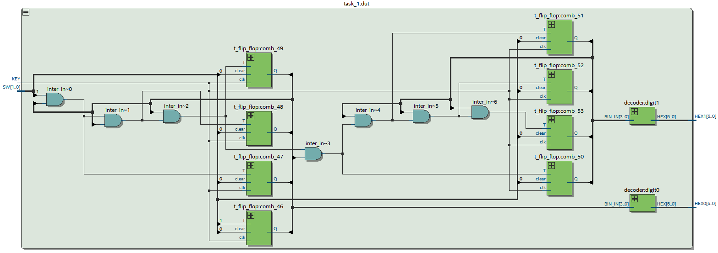

# Task 2

# Task 3

